CREATING AN EMAIL SIGNATURE
Signatures are not synced between your local and online accounts, so you will need to add your signature to both environments.

OUTLOOK ON COMPUTER
- Open Outlook on your computer
- Click on the FILE menu (top left)
- Click the OPTIONS link on the left side near the bottom
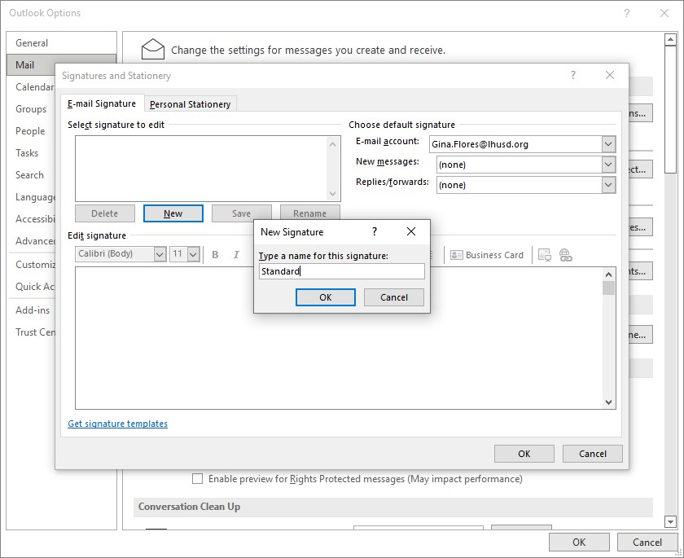
- Click the MAIL link on the left
- Click the SIGNATURES button
- Click the NEW button to create a new signature
- Type a name for your signature… signature, standard, normal, my signature, etc
- Click into the large Edit Signature text box
- Follow the district approved signature format below

Email signatures should have the following information; your name, position, site, phone and website address. Include the district mission statement, and school logo in either district or home school colors. You may keep other school logos or quotes.

Staff Name
Position
Site
School Phone Number
www.lhusd.org

The Lake Havasu Unified School District will engage each student with a focus on scholarship, character, and humanity – so that all students may graduate with the academic and social skills necessary to become responsible citizens and contributing members of society.

ADDING A LOGO TO YOUR SIGNATURE

Logos for each school and the District are located at the end of these instructions.
Use these to copy/paste into your signature.

COPY: click on your school logo to select it and press Ctrl+C on the keyboard or click the COPY tool from the toolbar (upper left) … or you can right-click on the logo and select COPY from the popup menu
PASTE: click into your signature text where you want the logo to appear and press Ctrl+V on the keyboard or click the PASTE tool from the toolbar (upper left) … or right-click where you want the logo and select PASTE from the popup menu.

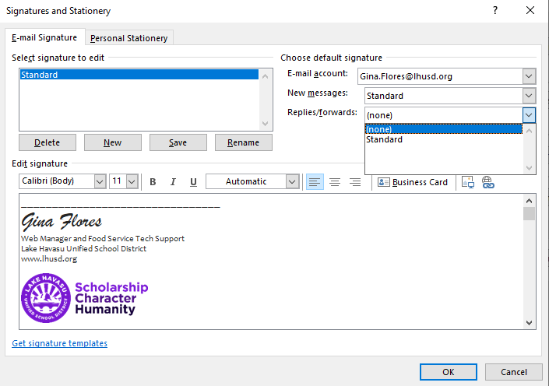
- Set the New messages and Replies/forwards signature defaults to your signature name
- Click OK to save your signature

- Click OK to close the Outlook Options window
- Create a new message to see if your signature shows up

If you have trouble, please submit a helpdesk ticket.

OUTLOOK IN BROWSER/MICROSOFT365
- Go to https://www.office.com and log in with your district credentials
  - Username: firstinitial last name @ lhusd.org (example: gflores@lhusd.org, jsmith@lhusd.org)
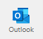
- Click the OUTLOOK icon in the left navigation bar to view your email.
  - If you can’t find it, click the waffle icon (9 dots) in the upper left corner of the webpage (left of the Microsoft 365 title).
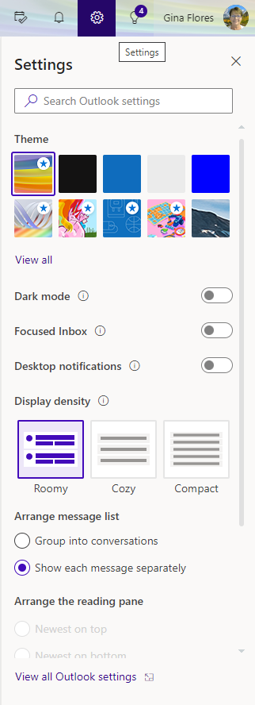
- Click the Settings icon (small gear icon at the top right – to the left of your name)

- Click the VIEW ALL OUTLOOK SETTINGS link at the bottom of the Settings panel
- Click the MAIL link on the left
- Click the COMPOSE AND REPLY link in the center column
- Click into the Edit Signature Name text box and type a name for your signature… can be anything – signature, standard, normal, my signature…
- Click into the large text box below the signature name
- Follow the district approved signature format below
Email signatures should have the following information; your name, position, site, phone and website address. Include the district mission statement, and school logo in either district or home school colors. You may keep other school logos or quotes.

Staff Name
Position
Site
School Phone Number
www.lhusd.org

The Lake Havasu Unified School District will engage each student with a focus on scholarship, character, and humanity – so that all students may graduate with the academic and social skills necessary to become responsible citizens and contributing members of society.

ADDING A LOGO TO YOUR SIGNATURE
Logos for each school and the District are located at the end of these instructions.
Use these to copy/paste into your signature.

COPY: click on your school logo to select it and press Ctrl+C on the keyboard or click the COPY tool from the toolbar (upper left) … or you can right-click on the logo and select COPY from the popup menu
PASTE: click into your signature text where you want the logo to appear and press Ctrl+V on the keyboard or click the PASTE tool from the toolbar (upper left) … or right-click where you want the logo and select PASTE from the popup menu.

- Click the SAVE button at the bottom right of the screen
- The signature name should appear for the New Messages and Replies/Forwards signature defaults
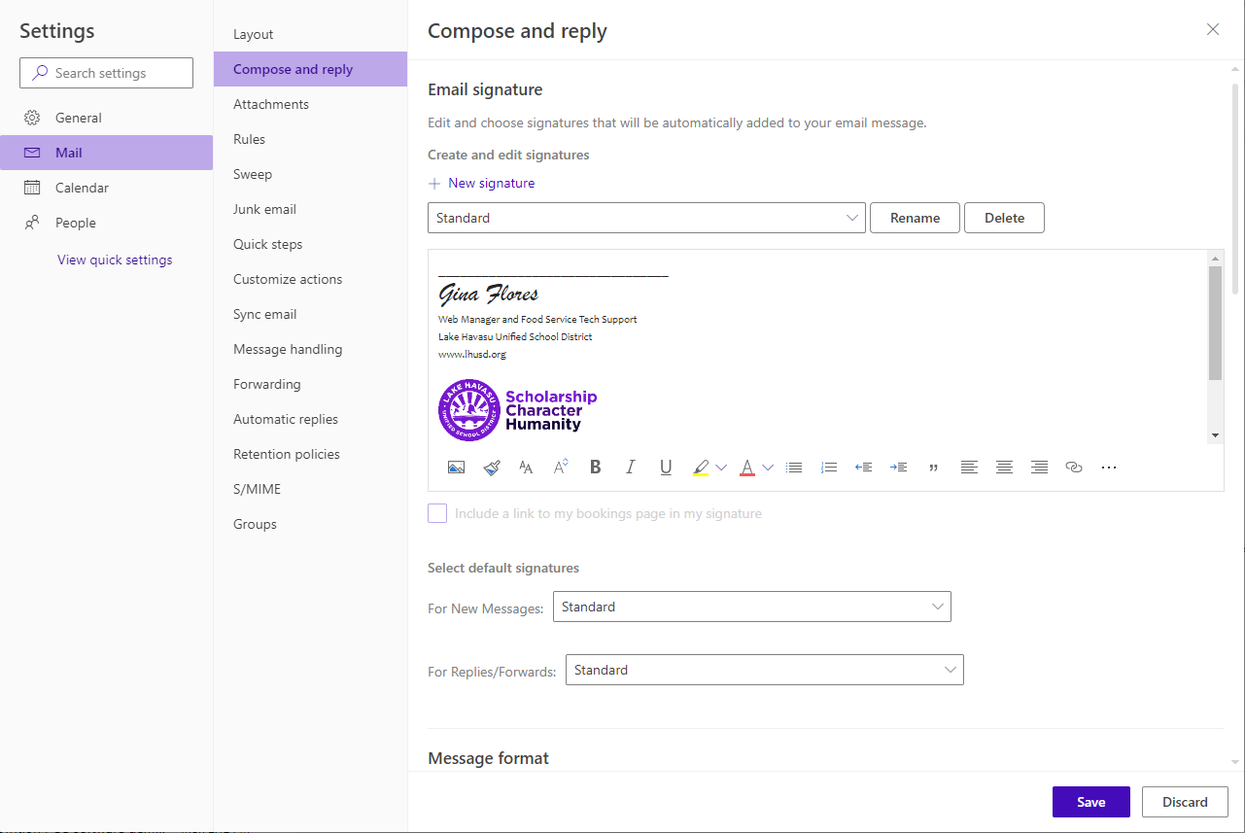

- Click SAVE once more – then close the Settings window (close X at top right)
- Create a new message to see if your signature shows up

If you have trouble, please submit a helpdesk ticket.

LOGOS – use for email signature
These logos have been resized to work best in the signature section of both local and online signatures.
Black and White
District
Havasupai
Jamaica
LHHS
Nautilus
Oro Grande
Smoketree
Starline
Thunderbolt

