Create New Section

Go to the Section screen

Make sure you have a section on the screen (any section is fine – just not the blank yellow fields for searching)

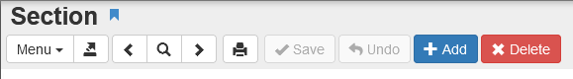
Click Add

If you do not see asterisks (**********) in the Section ID box STOP – close the window and make sure there is a section showing on the main Section screen

- Click the link to choose your Course ID – the title will automatically populate (do not change the course title)
- Click the link and choose the Staff Name
- Click the link and choose the Room Name
- Click the link and choose the Linked Staff Name if applicable
- Select the Begin and End Period
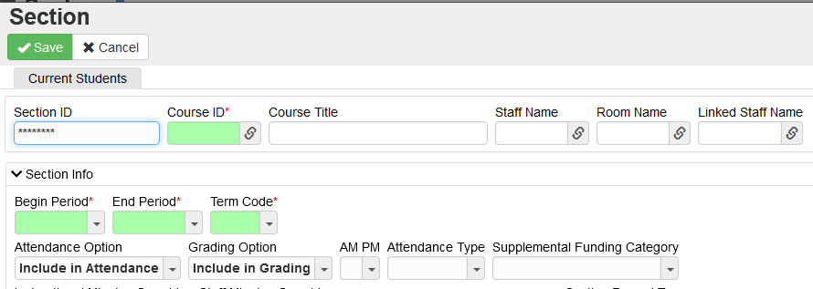
- Select the Term Code

Update the Attendance Option and Grading Option fields as needed.
Elementary School:
Attendance sections – Include in Attendance & Exclude from Grading
**KG attendance is set to Include for both fields
Subject sections – Exclude from Attendance & Include in Grading

Middle and High School:
All subject sections set to Include in Attendance & Grading

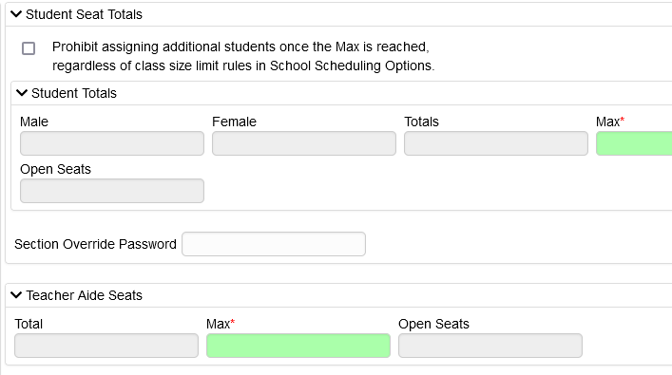

Enter Max number of students

Max number of Teacher Aides

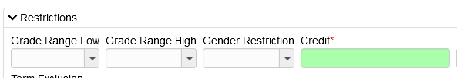

Enter Credit

Elementary & Middle School – enter 0
High School – enter .5
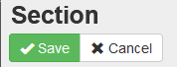

Click Save

