Duplicate a Section

Go to the Section screen

Find the section you want to copy
Search by Staff or Course ID/Title
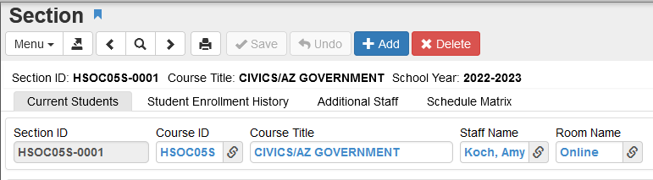

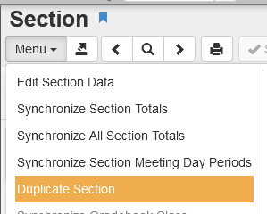

Go to Menu
Click on Duplicate Section

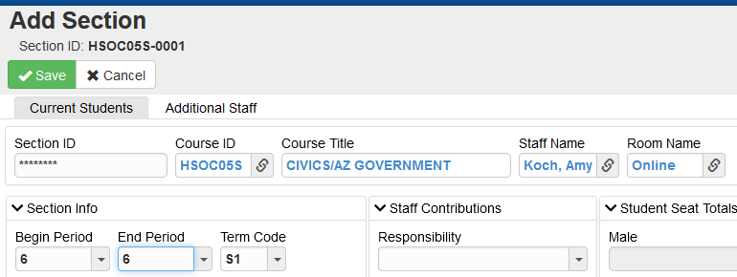

Update the Staff Name, Room Name, Begin/End Period, Term

Click Save

New section is now available

**NEVER change the Course ID or Course Title using this method of creating sections

