View Online Registration Documents

View date online registration was accepted by school:
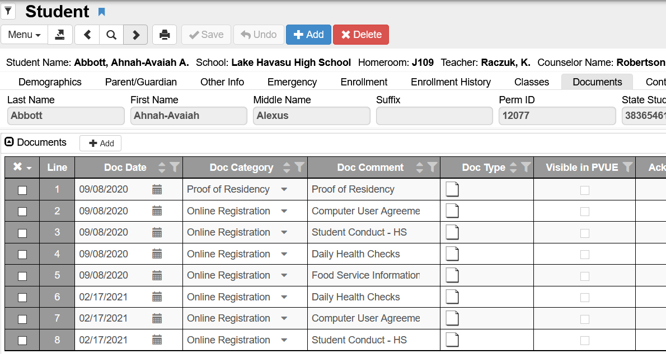

Go to the Student screen > Documents tab

You can see the list of documents processed through online registration
Click on the paper icon if you want to view the document

View the date/time stamp of the parent/guardian signature:
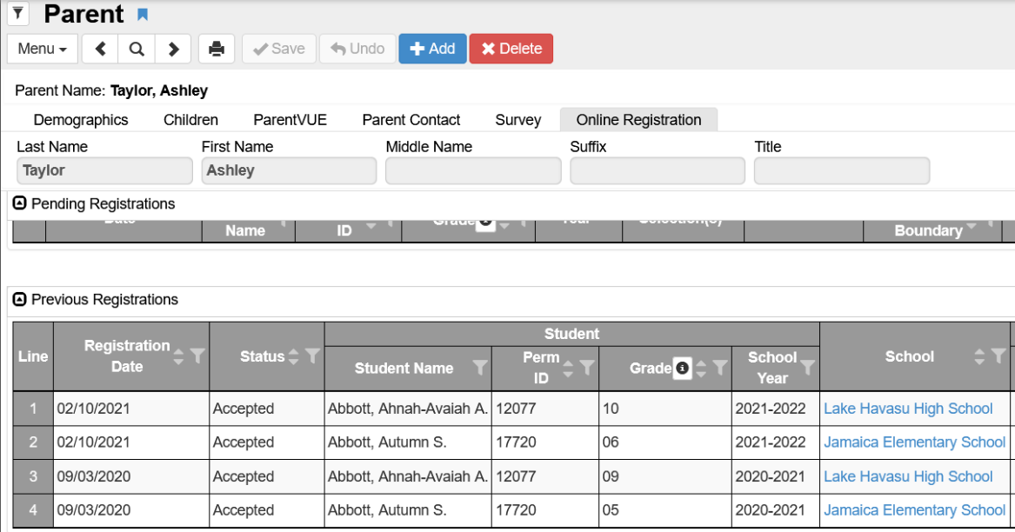
Student Name & ID show here
Go to the Parent screen > Online Registration tab

Scroll to Previous Registrations area to see accepted registrations

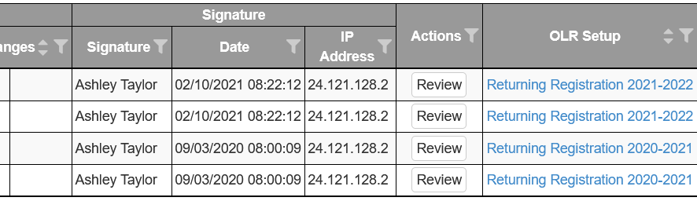
Parent Name shows here

Scroll to the right to see who electronically signed the form and the date/time is was signed

